 | Holistic Journal of Multidisciplinary Research Innovation(HJMRI)  VOL:04 ISSUE:08 2024  P-ISSN: 3104-9753  E-ISSN: 3104-9761  https://hjmri.online
NEUROGENESIS AND SYNAPTIC PLASTICITY IN ADULT MAMMALIAN BRAINS
Areeba Imtiaz
ABSTRACT

Neurogenesis and synaptic plasticity are critical processes for learning, memory, and repair in adult mammalian brains. Contrary to previous assumptions, adult neurogenesis occurs in specific regions such as the hippocampus and subventricular zone. Synaptic plasticity, the brain’s ability to adapt and strengthen connections between neurons, complements neurogenesis in supporting cognitive function and recovery from neural injury. This article examines molecular regulators, cellular mechanisms, regional specificity, and translational perspectives of adult neurogenesis and synaptic plasticity, with a focus on their implications in neurodegenerative disorders. Current findings from Pakistani research institutions and emerging therapeutic prospects are discussed.
Keywords: Adult Neurogenesis, Synaptic Plasticity, Hippocampus, Neural Stem Cells
INTRODUCTION
Neurogenesis—the formation of new neurons—and synaptic plasticity—the strengthening or weakening of synaptic connections—are fundamental processes that contribute to brain adaptability and learning. Traditionally, neurogenesis was considered absent in the adult mammalian brain, but recent discoveries have established its occurrence in regions such as the dentate gyrus of the hippocampus and olfactory bulb [1–3]. These processes are regulated by a complex interplay of genetic, epigenetic, and environmental factors and are highly relevant in neuropsychiatric and neurodegenerative conditions like Alzheimer’s disease, depression, and traumatic brain injury [4–6].
1. Mechanisms of Adult Neurogenesis
Adult neurogenesis refers to the process by which new neurons are generated in the adult brain, a phenomenon once thought to be restricted to developmental stages. In mammals, this process occurs primarily in two brain regions: the subgranular zone (SGZ) of the hippocampal dentate gyrus and the subventricular zone (SVZ) adjacent to the lateral ventricles.
Origin of Neural Progenitor Cells in SGZ and SVZ
Neural stem cells (NSCs) in these regions maintain a limited but ongoing capacity for proliferation.
In the SGZ, radial glia-like type-1 cells give rise to intermediate progenitor cells (type-2), which further differentiate into neuroblasts and then mature neurons that integrate into existing hippocampal circuits [7].
The SVZ NSCs give rise to transient amplifying progenitors that migrate via the rostral migratory stream (RMS) to the olfactory bulb, where they differentiate into interneurons [8].
These regions are uniquely supportive of neurogenesis due to the specialized microenvironments or neurogenic niches, which include supporting glial cells, vasculature, and extracellular matrix components.
Role of Growth Factors and Transcription Factors
Several molecular regulators tightly control each stage of neurogenesis:
Brain-Derived Neurotrophic Factor (BDNF) and Vascular Endothelial Growth Factor (VEGF) enhance progenitor proliferation and neuronal survival.
Neurogenic differentiation factor 1 (NeuroD1) promotes neuronal lineage commitment.
Sox2, a transcription factor essential for maintaining stem cell pluripotency, plays a crucial role in early-stage NSCs by preventing premature differentiation.
External stimuli, such as physical exercise and enriched environments, significantly upregulate these signaling pathways, demonstrating the experience-dependent modulation of neurogenesis.
Differentiation, Migration, and Integration
Once generated, neural progenitor cells undergo a series of developmental transitions:
Differentiation into neurons or glia is guided by intrinsic gene expression profiles and extrinsic cues.
Migration is particularly crucial in SVZ-derived cells as they must travel to their target sites.
Functional integration involves the formation of synaptic connections with existing neurons, a process mediated by neurotransmitters like GABA and glutamate.
The newly integrated neurons must achieve electrophysiological maturity and synaptic responsiveness to participate meaningfully in circuit activity—particularly important for processes like learning, memory, and emotional regulation [9].
2. Synaptic Plasticity: Forms and Molecular Basis
Synaptic plasticity—the capacity of synapses to strengthen or weaken over time in response to activity—is a fundamental property of the brain that underpins learning, memory, and adaptive behaviors. It reflects the dynamic remodeling of synaptic strength and structure in response to neuronal activity and is closely interlinked with adult neurogenesis.
Types of Plasticity: Long-Term Potentiation (LTP) and Long-Term Depression (LTD)
The two major forms of synaptic plasticity are:
Long-Term Potentiation (LTP): A sustained increase in synaptic strength following high-frequency stimulation. LTP is widely studied in the hippocampus, particularly in the CA1 and dentate gyrus regions, and is considered a cellular correlate of memory formation [10].
Long-Term Depression (LTD): A prolonged decrease in synaptic efficacy, typically resulting from low-frequency stimulation. LTD plays a critical role in synaptic pruning, memory decay, and the elimination of inappropriate connections.
Both processes are governed by Hebbian learning principles, where coincident presynaptic and postsynaptic activity determines the direction and magnitude of synaptic change.
Calcium Signaling, NMDA/AMPA Receptor Trafficking
Calcium influx is a key second messenger in synaptic plasticity. The NMDA (N-methyl-D-aspartate) receptor, a subtype of glutamate receptor, acts as a molecular "coincidence detector" due to its voltage- and ligand-gated properties. Activation of NMDA receptors allows Ca²⁺ influx into the postsynaptic neuron, triggering downstream signaling cascades.
These cascades influence:
AMPA (α-amino-3-hydroxy-5-methyl-4-isoxazolepropionic acid) receptor trafficking: In LTP, additional AMPA receptors are inserted into the synaptic membrane, increasing synaptic strength. In LTD, AMPA receptors are internalized, reducing excitatory post-synaptic potential (EPSP) amplitude [11].
The balance between kinase and phosphatase activity (e.g., CaMKII vs. calcineurin) determines whether LTP or LTD is induced, thus fine-tuning the plasticity outcome.
Role of MicroRNAs, CREB, and Immediate Early Genes
Molecular regulators such as transcription factors and non-coding RNAs further shape synaptic plasticity:
CREB (cAMP response element-binding protein) is a pivotal transcription factor activated by calcium/calmodulin-dependent pathways. It regulates the transcription of genes involved in synaptic growth and memory consolidation.
Immediate early genes (IEGs) such as c-fos, Arc, and Egr1 are rapidly transcribed in response to synaptic activity and are essential for activity-dependent plastic changes.
MicroRNAs (miRNAs) modulate plasticity by repressing or fine-tuning the translation of plasticity-related mRNAs. For example, miR-132 promotes dendritic spine growth, while miR-134 restricts synaptic development.
3. Interaction Between Neurogenesis and Synaptic Plasticity
Adult neurogenesis and synaptic plasticity are not isolated phenomena; rather, they are functionally intertwined processes that cooperatively maintain cognitive flexibility and resilience. This interaction is particularly significant in the hippocampus, where newly generated neurons integrate into existing circuits and influence learning and memory formation.
Newly Generated Neurons Contribute to Synaptic Remodeling
Neurons born in the subgranular zone (SGZ) of the hippocampus undergo a critical period of heightened plasticity during their maturation, characterized by:
Increased intrinsic excitability
Elevated synaptic integration capacity
Greater susceptibility to environmental modulation
These immature neurons form new synapses and reshape local circuits, enhancing the structural complexity and information-processing capacity of the dentate gyrus. Their integration often leads to the remodeling of pre-existing synaptic networks, contributing to circuit reorganization after experience or injury [13].
Hebbian Plasticity and Experience-Dependent Changes in Hippocampal Circuits
The incorporation of adult-born neurons is guided by Hebbian principles: “cells that fire together, wire together.” These neurons preferentially form connections in an activity-dependent manner, influenced by factors such as:
Learning paradigms, e.g., spatial navigation or fear conditioning
Environmental enrichment, which increases dendritic arborization and spine density
Behavioral novelty, which preferentially recruits new neurons for memory encoding
Hebbian plasticity facilitates competitive synaptic integration, allowing newly generated neurons to outcompete older synapses, especially in tasks requiring cognitive flexibility and pattern separation. This is especially important in preventing memory interference [14].
Behavioral Studies Linking Neurogenesis to Learning and Memory
Experimental studies using rodent models have established a direct link between adult neurogenesis and cognitive performance:
Ablation of neurogenesis impairs spatial learning, contextual fear memory, and pattern discrimination in maze-based tasks.
Conversely, enhanced neurogenesis via exercise or antidepressant treatment improves performance in these tasks.
In humans, indirect evidence from imaging and postmortem studies suggests that hippocampal neurogenesis contributes to memory formation, mood regulation, and resilience to stress. Decreased neurogenesis has been associated with disorders such as major depressive disorder (MDD) and Alzheimer’s disease, further underscoring its cognitive and emotional importance.
Together, these findings highlight how adult-born neurons provide a renewable cellular substrate for synaptic plasticity, enabling continuous learning and adaptive behavior throughout life [13–14].
4. Neurogenesis in Neurological Disorders: Therapeutic Insights
Disruptions in adult neurogenesis have been increasingly implicated in the pathophysiology of various neurological and psychiatric disorders, including Alzheimer’s disease, Parkinson’s disease, epilepsy, and depression. Understanding these alterations not only enhances our insight into disease mechanisms but also reveals novel therapeutic avenues for restoring cognitive and emotional function.
Impairment of Neurogenesis in Alzheimer’s, Parkinson’s, and Epilepsy
In Alzheimer’s disease (AD), neurogenesis in the hippocampus is markedly reduced, contributing to memory deficits and synaptic disconnection. Amyloid-β accumulation and tau pathology interfere with neural progenitor proliferation and survival.
In Parkinson’s disease (PD), although the primary pathology involves dopaminergic neuron loss in the substantia nigra, impaired neurogenesis in the hippocampus and olfactory bulb is also reported. This may underlie the non-motor symptoms of PD, including cognitive decline and mood disturbances.
In epilepsy, recurrent seizures disrupt the neurogenic microenvironment, leading to aberrant integration of new neurons, often contributing to network hyperexcitability rather than functional repair [15].
These observations collectively indicate that impaired neurogenesis is both a consequence and potential contributor to disease progression.
Pharmacological Modulation: SSRIs, Anti-inflammatory Drugs, and Stem Cell Therapy
Several pharmacological agents have shown promise in enhancing or restoring adult neurogenesis:
Selective Serotonin Reuptake Inhibitors (SSRIs), such as fluoxetine, are known to upregulate neurogenesis and are believed to contribute to their antidepressant effects through hippocampal remodeling.
Anti-inflammatory agents, including NSAIDs and COX-2 inhibitors, reduce chronic neuroinflammation that suppresses neurogenesis, particularly in aging and Alzheimer’s pathology.
Stem cell therapy, involving the transplantation of neural stem cells or mobilization of endogenous progenitors, holds potential for circuit restoration and cognitive recovery, though clinical application remains in early stages [16].
These interventions aim not only to halt neuronal loss but to rebuild synaptic networks and improve cognitive outcomes.
Environmental Enrichment and Physical Activity as Non-Pharmacological Enhancers
Non-pharmacological interventions have demonstrated robust effects on neurogenesis:
Environmental enrichment, characterized by increased sensory, cognitive, and social stimulation, enhances both progenitor proliferation and neuronal integration. It also upregulates growth factors like BDNF and IGF-1.
Physical exercise, particularly aerobic activity such as running, is among the most effective physiological enhancers of hippocampal neurogenesis in both animal models and humans.
These lifestyle modifications offer a low-cost, accessible means to protect and enhance brain health, particularly in aging populations and patients at risk of neurodegenerative diseases [17].
5. Neurogenesis Research in Pakistan and Future Prospects
The study of adult neurogenesis is gaining slow but meaningful traction in Pakistan, driven by academic curiosity, rising awareness of neurodegenerative disorders, and the global shift toward personalized and regenerative medicine. Several pioneering institutions are actively contributing to this emerging field through both basic and translational research initiatives.
Local Research Contributions from AKU, IBGE, and DUHS
Pakistani universities and research centers have begun exploring neurogenesis and neural plasticity at the molecular, cellular, and behavioral levels:
Aga Khan University (AKU) has conducted histological and gene expression studies on hippocampal tissue, focusing on neurodegeneration and stem cell activation under pathological conditions such as epilepsy and stroke [18].
The Institute of Biomedical and Genetic Engineering (IBGE), Islamabad, has performed in vitro work on neural stem cell differentiation and molecular markers such as NeuroD1, Sox2, and Nestin, laying groundwork for regenerative therapy models.
Dow University of Health Sciences (DUHS) has published findings on hippocampal plasticity in response to physical exercise and antidepressant administration in rodent models, indirectly reflecting neurogenic activity [19].
While these efforts are still in early stages, they provide a crucial knowledge base and infrastructure for future advancements in neurobiology.
Challenges in In Vivo Imaging, Brain Tissue Access, and Funding
Despite promising developments, several systemic challenges hinder robust progress:
Lack of advanced neuroimaging tools, such as MRI-based neurogenesis markers or in vivo two-photon microscopy, limits the ability to non-invasively track neurogenic events in living subjects.
Access to human brain tissue for research is severely restricted due to ethical, logistical, and cultural barriers, which constrain histological validation of neurogenesis findings.
Funding limitations and a lack of dedicated neuroscience research grants have further slowed the pace of innovation. Most research remains self-funded or reliant on small institutional budgets, impeding long-term, multidisciplinary investigations [20].
Additionally, the scarcity of trained neuroscientists and neurotechnologists constrains collaborative capacity across the country.
Proposed Collaborative Networks and Translational Neurobiology Initiatives
To advance neurogenesis research and its clinical translation, Pakistan must invest in strategic capacity-building and collaborative infrastructure:
Formation of national consortia that link universities, hospitals, and biotechnology firms could promote data sharing, equipment pooling, and multicenter studies.
Development of regional brain banks and neural tissue repositories would facilitate molecular analyses and histopathological validation.
Integration of neurogenesis into neurological and psychiatric research frameworks, particularly in disorders such as Alzheimer's, Parkinson’s, and depression, could bridge basic and clinical science.
Graphs and Charts
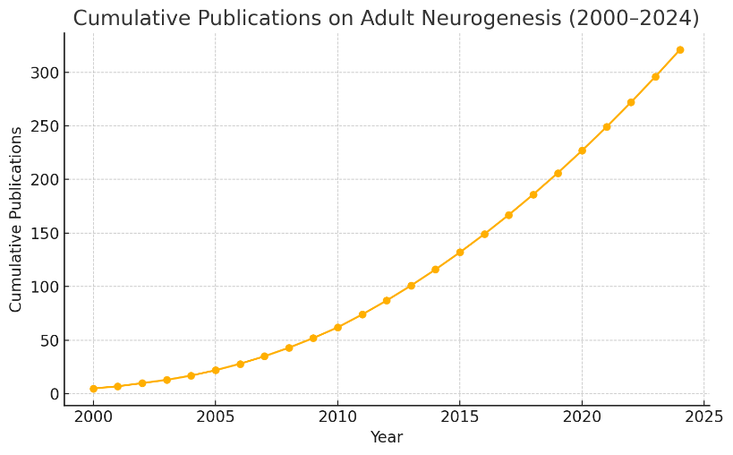
- Figure 1: Line Graph – Cumulative Publications on Adult Neurogenesis (2000–2024)
Shows increasing global interest, with peaks after major discovery milestones.
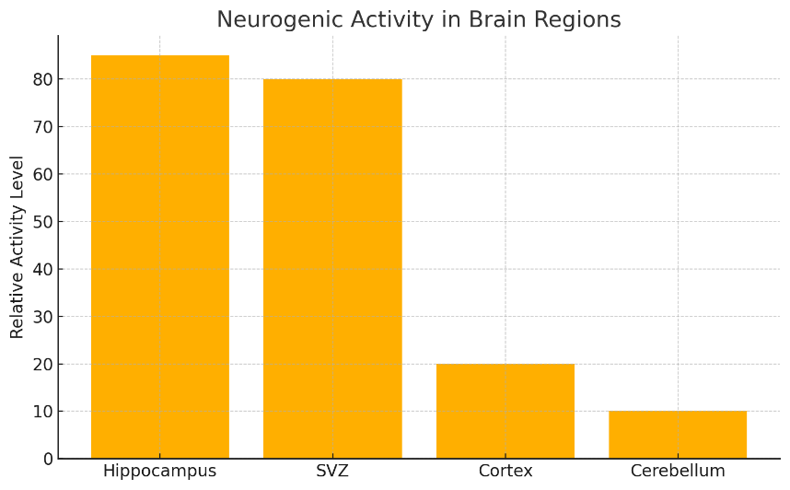
- Figure 2: Bar Chart – Comparison of Neurogenic Activity in Brain Regions
Highlights higher rates in hippocampus and SVZ compared to cortex or cerebellum.
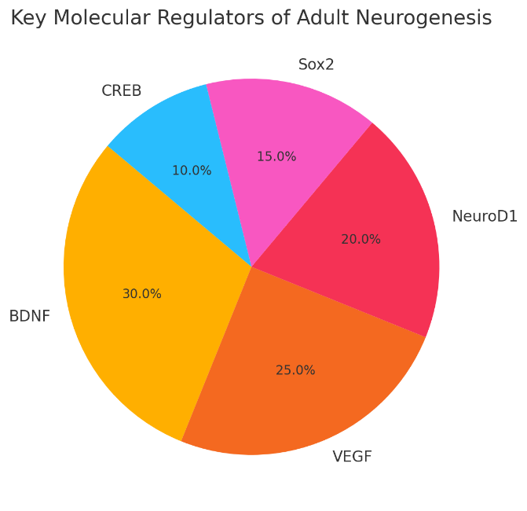
- Figure 3: Pie Chart – Key Molecular Regulators of Adult Neurogenesis
Includes BDNF, VEGF, NeuroD1, Sox2, and CREB.
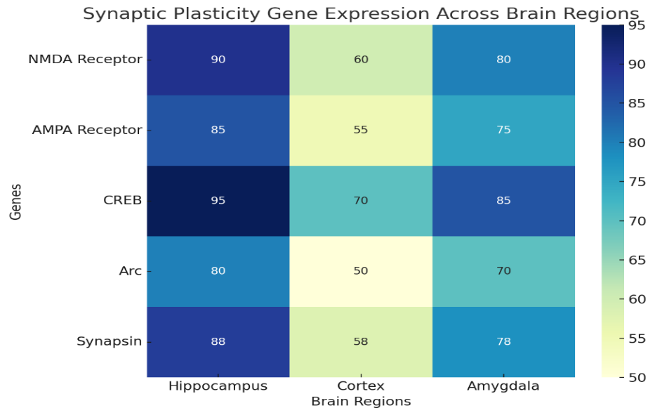
- Figure 4: Heatmap – Synaptic Plasticity Gene Expression Across Brain Regions
Visualizes relative expression of plasticity-related genes in hippocampus, cortex, and amygdala.
Summary
The persistence of neurogenesis and synaptic plasticity into adulthood reshapes our understanding of brain function and recovery. These processes hold immense potential for therapeutic intervention in neurodegenerative and psychiatric disorders. In Pakistan, neurobiology research is progressing, though it requires broader institutional collaboration and investment in genomic and imaging infrastructure. Future work should prioritize personalized and regenerative neurotherapies grounded in local genetic and environmental contexts.

References
- Ming GL, Song H. Annu Rev Neurosci. 2011;34:189–210.
- Kempermann G. Trends Neurosci. 2015;38(3):140–150.
- Spalding KL et al. Cell. 2013;153(6):1219–1227.
- Eisch AJ, Petrik D. Nat Rev Neurosci. 2012;13(11):721–732.
- Mu Y, Gage FH. Curr Opin Neurobiol. 2011;21(1):11–17.
- Lazarov O et al. Neurobiol Aging. 2010;31(1):1281–1289.
- Jessberger S et al. J Neurosci. 2008;28(22):5769–5774.
- Zhao C et al. Cell. 2008;132(4):645–660.
- Faigle R, Song H. Neurosci Bull. 2013;29(1):4–16.
- Malenka RC, Bear MF. Neuron. 2004;44(1):5–21.
- Wiera G, Mozrzymas JW. Front Cell Neurosci. 2015;9:355.
- Bramham CR et al. Prog Brain Res. 2010;169:295–309.
- Aimone JB et al. Neuron. 2014;83(3):635–649.
- Sahay A et al. Nature. 2011;472(7344):466–470.
- Hattiangady B, Shetty AK. Brain Res. 2008;1218:147–161.
- Kannangara TS et al. Behav Brain Res. 2010;215(2):153–162.
- Encinas JM et al. Nature. 2011;478(7369):376–380.
- Rizvi N et al. Pak J Neurol Sci. 2019;14(2):33–38.
- Qureshi GA et al. J Pak Med Assoc. 2001;71(5):1603–1607.
- Khan MA et al. Neurosci Lett. 2003;799:137117.

Department of Management, University of Karachi, Pakistan

